Objective
The objective of lab assignments 6 through 10 are to systematically design and implement an FPGAbased
keypad scanner. The keypad scanner will utilize a FIFO for data storage and retrieval, a display mux, and the seven-segment displays, slide switches, and LEDs of the Digilab XLA prototyping board. The top level block diagram of the system is shown in Figure 1 and the I/O in Table 1. When a button of the hex keypad is pressed the system must decode the button and store the data in an internal FIFO. The read button will be used to read data from the FIFO and display the data on the seven-segment displays. The mode_toggle input will be used to toggle between display states so that more than eight signals can be presented for view on the LED’s. The LEDs will display the status of the FIFO and other information. The hardware prototype will be verified to operate with the Grayhill 072 hex Keypad. A system partition is shown in Figure 2. As input mode_toggle is depressed output DGrp will toggle between DGrp1, DGrp2, and DGrp3 as denoted in Table 2.
Figure 1: 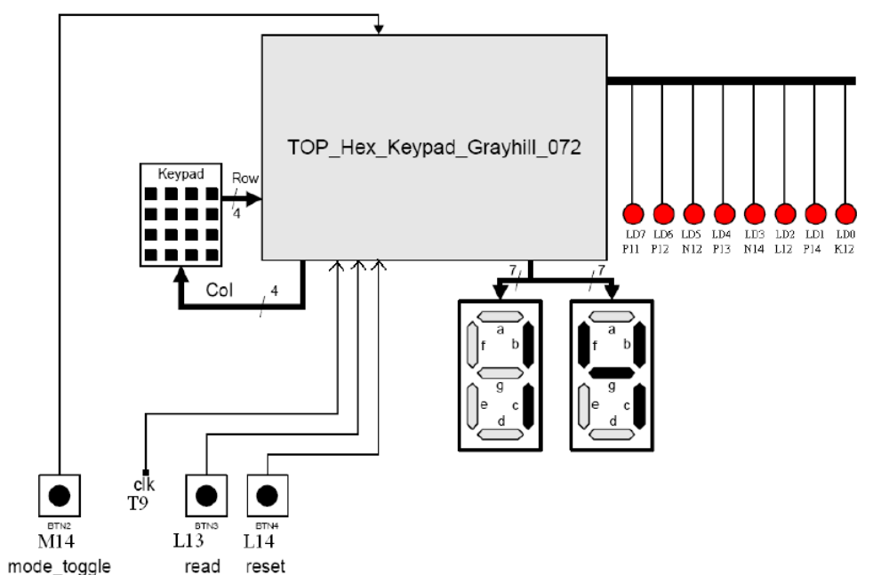
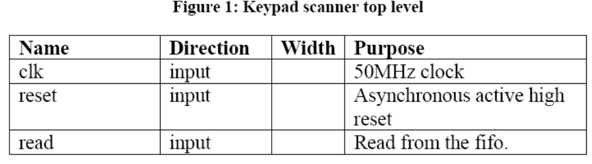
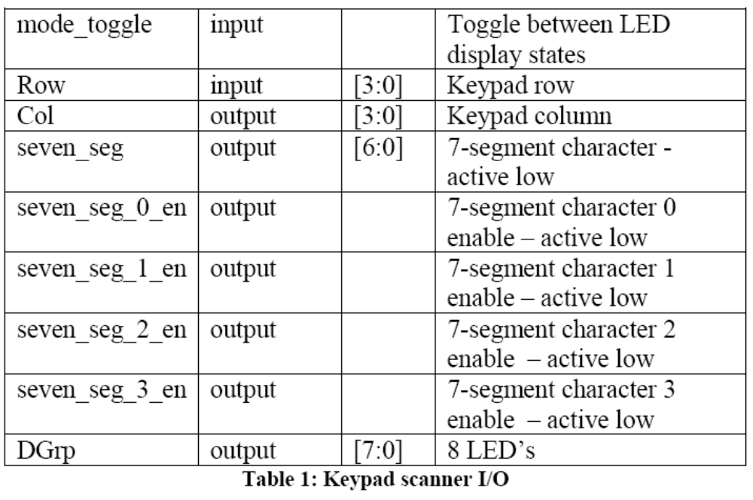
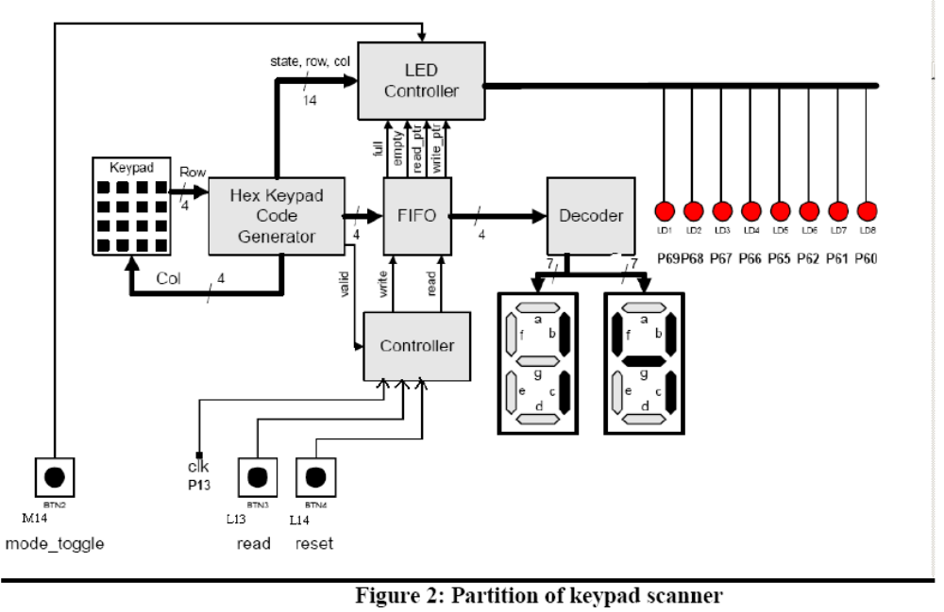
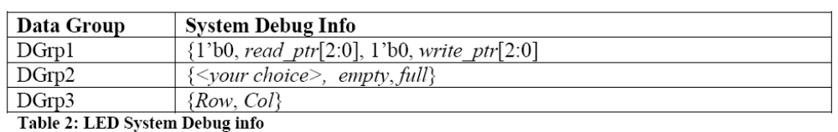
The objective of this lab is to design and test the keypad scanner/encoder. This lab will be completed individually.
Keypad Scanner
Keypad scanners are used to enter data manually in digital telephones, computer keyboards and other digital systems. Telephones have a decimal keypad, and computer keyboards usually have a hexadecimal
keypad. A keypad scanner responds to a pressed key and forms a code that uniquely identifies the key that is pressed. It must take into account the asynchronous nature of the inputs and deal with switch debounce. Also, in some applications, it must not interpret a key to be pressed repeatedly if it is pressed once and held down. We will use a synchronizer to synchronize the asynchronous inputs and a debounce circuit to debounce the synchronized input.
Let's consider a scheme for designing a scanner/decoder for the hexadecimal keypad circuit shown in Figure 3. A pressed button establishes a connection between a row and a column at the location of the
button. Each row is connected to a pull-down resistor, and is connected to a column when a keypad button is pressed. If a column line is connected to the supply voltage, a row that is connected to that column by a pressed button will be pulled to the supply voltage too; otherwise the row line is pulled down to 0 V. The keypad code generator unit has control over the column lines, and will exercise that control to detect the location of a pressed button.
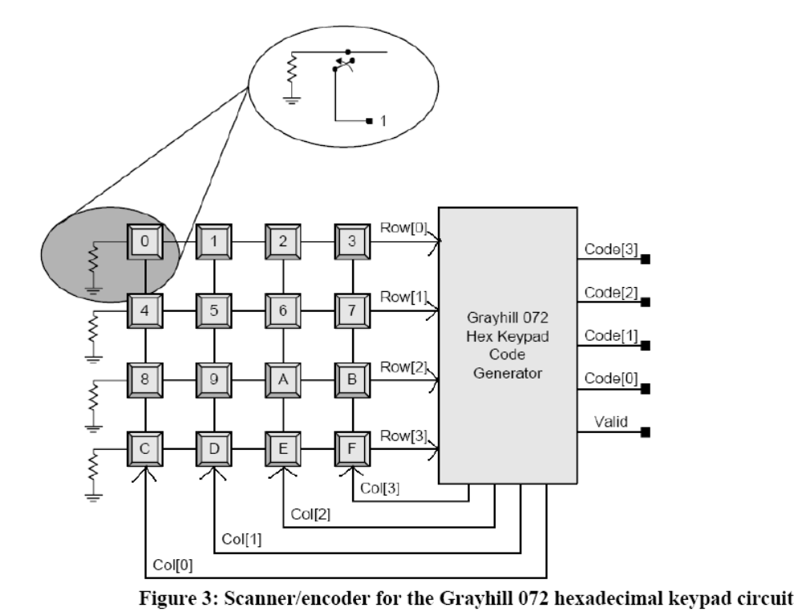
A keypad code generator must implement a decoding scheme that (1) detects whether a button is
pressed, (2) identifies the button that is pressed, and (3) generates an output consisting of the unique code
of the button. The decoding scheme will be implemented as a synchronous sequential machine with thebutton codes shown in Table 3. The outputs of the machine are the column lines, the code lines, and a
signal, Valid, that indicates a valid code. Note that for each key press Valid will only be asserted for 1
clock cycle to indicate a valid signal on Code. This is true even if a key is pressed and held down.
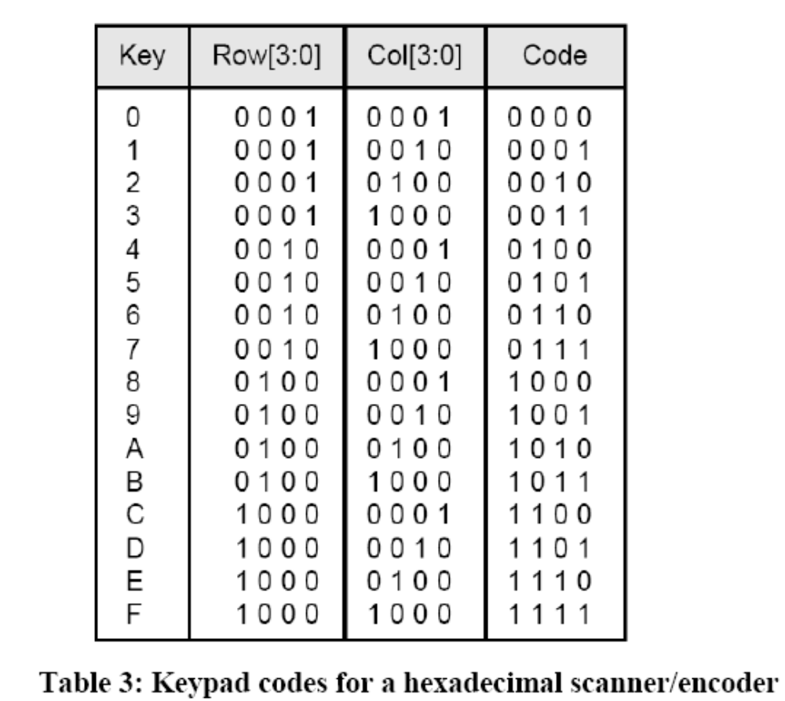
The pin-out of the ribbon cable for the keypad is Figure 4. The column (Col) is scanned by
driving a 1 across each column and observing the value of Row. From this information it can be
determined what button was pressed. For example if Col[2] is driven to 1 and a 1 is observed on
row[1] key 6 has been pressed.
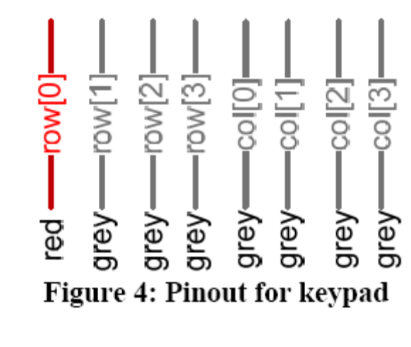Synchronization Circuit
The input from the keypad, Row, is asynchronous. Any flip-flop that uses input Row will have to
meet that flip-flip’s setup or hold time requirement as depicted in Figure 5. When a flip-flip’s
setup/hold time requirement is not met the flip-flop’s output may be unknown for a period of
time.
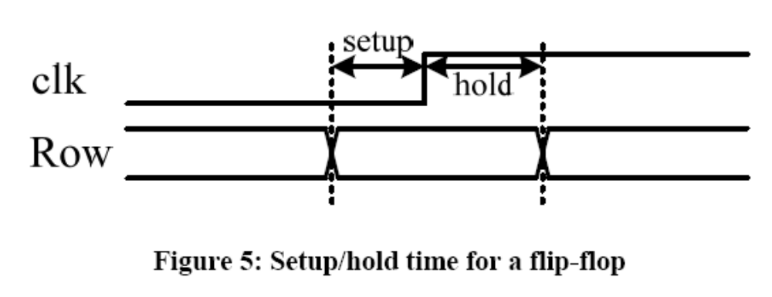
To combat this problem a synchronization circuit will be used as depicted in Figure 6 with the behavior
as depicted in Figure 7. The clk signal is connected to the high speed system clock.
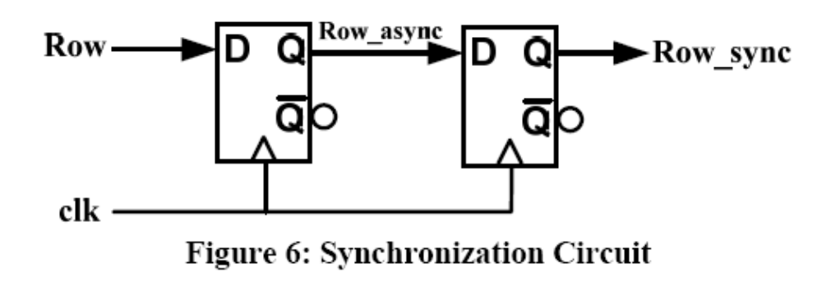
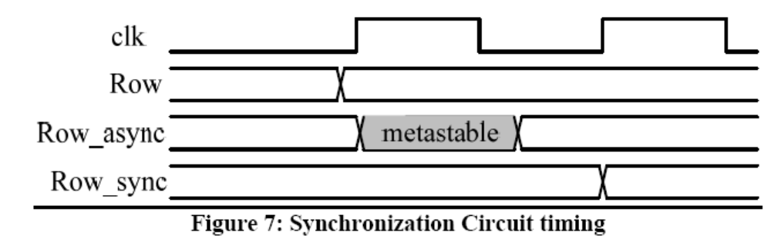
The Row input can bounce for many milliseconds. There are many possibilities for de-bounce
circuits. One possibility is to create a very slow divided down clock (~100Hz) and if Row is the
same value on two clock edges then Row is considered to have stabilized. Another possibility
that does not require dividing down the clock is a counter that will count the number of times a
potential transition has occurred. For example, if the current de-bounced value is a zero, the
counter will count the number of sequential ones detected. If a zero is detected the counter is
reset. When the counter reaches a set value the de-bounced value will be set to a 1. Then the
counter begins to look for a zero.

